IMPETUS CORPORATION

EE 493 Design Studio 1

Weekly Report

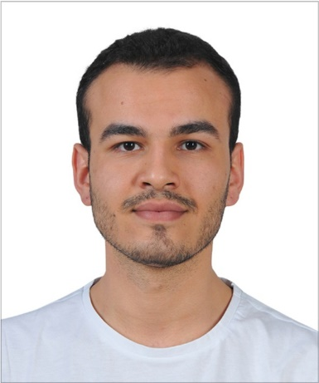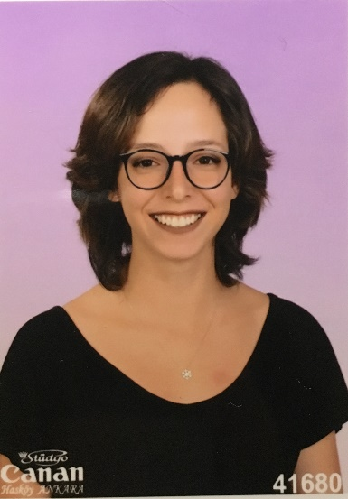

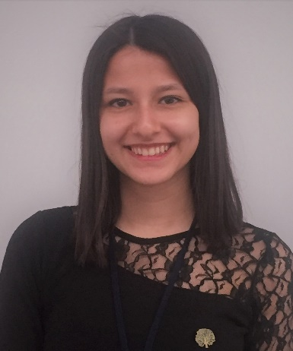

Elif Merve ÖZALP Emre Deniz ŞENEL Fahri TÜREDİ

2329746 2167237 2167435



Melike YILDIRIM Yunus YİLMAZ

2167591 2167658

**WEEKLY REPORT**

1. **Summary of progress in the last week:**

* Created GitHub accounts. Tutorial was done for GitHub learning.
* Created Google Groups and common mail account.
* Assigned responsibilities for each member for Business Statement Report.
* Discussed on design projects.
* Determined the name of the company and designed the logo.

1. **Questions to be discussed at this meeting:**

Questions about the Autonomous Valet Parking Service project :

* Can we implement a smart grid?
* Should the grids be symmetric?
* Can the positions of the cars be changed after the delivery?
* Can we utilize line tracking functionality for the coordination of the valet system?
* Which status informations about the car should we present on the app?

General questions:

* What should we work on for the next week?

1. **Plans for next week:**

* Complete Business Statement Report.
* Detailed discussion on each design project, doing more research on them.
* Literature research for the projects.